**CHAPTER 1**

**INTRODUCTION**

**1.1 OVERVIEW OF THE PROJECT**

The IoT-based Accident Alert project aims to revolutionize road safety by leveraging Internet of Things (IoT) technology to detect accidents in real-time and promptly alert relevant authorities and nearby vehicles. This innovative system integrates sensors installed in vehicles and road infrastructure to continuously monitor road conditions and vehicle movements. Sophisticated algorithms analyze sensor data to accurately differentiate between normal driving conditions and accident scenarios, minimizing false alarms. Upon detecting an accident, the system automatically generates alerts containing precise location information and severity assessment, which are transmitted to emergency services, nearby vehicles, and designated contacts through various communication channels such as Wi-Fi, cellular networks, and IoT cloud platforms. By enhancing emergency response times and enabling proactive measures to prevent accidents, this project aims to significantly improve road safety and mitigate the impact of accidents on lives and property.

**Key Components:**

Sensor Integration: The system incorporates various sensors, including accelerometers, gyroscopes, GPS modules, and Wi-Fi modules, embedded in vehicles and road infrastructure. These sensors continuously monitor road conditions and vehicle movements, enabling the early detection of potential accidents

Data Analysis: Advanced algorithms analyze sensor data to differentiate between normal driving conditions and accident scenarios accurately. Machine learning techniques are employed to enhance the system's accuracy in accident detection and minimize false alarms.

Communication Infrastructure: Utilizing Wi-Fi, cellular networks, and IoT cloud platforms, the system transmits accident alerts to emergency services, nearby vehicles, and designated contacts. This ensures prompt notification and enables timely medical assistance and accident management.

User Interface: An intuitive user interface provides stakeholders with access to real-time accident data, including precise accident location information, vehicle identification, and severity assessment. This facilitates informed decision-making and efficient coordination of emergency response efforts.

**Advantages:**

Enhanced Road Safety: By promptly notifying emergency services and nearby vehicles, the system reduces response times and enables proactive measures to avoid accidents, thereby enhancing road safety.

Real-time Monitoring: The system's real-time monitoring capabilities offer valuable insights into traffic patterns, accident hotspots, and road conditions, facilitating data-driven decision-making for urban planning and infrastructure improvements.

Scalability and Adaptability: The automated nature of the system allows for scalability and adaptability to different environments and use cases. It can be easily integrated with existing infrastructure and adapted to suit specific requirements.

**1.2 MOTIVATION FOR THE PROBLEM**

The motivation behind the development and implementation of the IoT-based Accident Alert System is rooted in the urgent need to address the persistent and devastating consequences of road accidents. Despite advancements in vehicle safety technologies and road infrastructure, road accidents remain a significant global concern, claiming millions of lives annually and causing extensive injuries, disabilities, and economic losses. Traditional methods of accident detection and emergency response often suffer from inefficiencies, delays, and inaccuracies, leading to increased severity of accidents and hindering timely assistance to those in need. The staggering statistics surrounding road accidents underscore the critical importance of adopting innovative solutions to enhance road safety. The integration of Internet of Things (IoT) technologies presents a promising approach to address this pressing issue by leveraging real-time data collection, analysis, and communication capabilities. By embedding sensors in vehicles and road infrastructure, the IoT-based Accident Alert System enables continuous monitoring of road conditions, vehicle movements, and environmental factors that may contribute to accidents. The primary motivation for implementing this system is to revolutionize the way accidents are detected, responded to, and managed on roads. By harnessing IoT technology, the system aims to detect accidents in real-time and promptly alert relevant authorities, emergency services, and nearby vehicles. This proactive approach significantly reduces response times, facilitates timely medical assistance, and minimizes the severity of accidents, ultimately saving lives and reducing the impact on public health and safety. Furthermore, the IoT-based Accident Alert System aligns with broader societal goals of leveraging technology for social good and enhancing the quality of life for communities worldwide. Beyond its immediate impact on road safety, the system has the potential to transform transportation systems, urban planning, and emergency response strategies. By providing valuable insights into traffic patterns, accident hotspots, and road conditions, the system enables data-driven decision-making and targeted interventions to improve road infrastructure and enhance overall public safety.

**1.3 OBJECTIVE OF PROJECT**

The primary objective of implementing the IoT-based Accident Alert System is to revolutionize road safety by leveraging Internet of Things (IoT) technology to detect accidents in real-time, promptly notify relevant authorities and nearby vehicles, and mitigate the severity of accidents. This innovative system aims to address the pressing need for efficient accident detection and emergency response strategies to reduce the alarming rate of road accidents and their devastating consequences.

**Real-Time Accident Detection:** The foremost objective of the IoT-based Accident Alert System is to detect accidents as they occur on roads in real-time. By integrating sensors embedded in vehicles and road infrastructure, the system continuously monitors road conditions, vehicle movements, and environmental factors to identify anomalies indicative of potential accidents.

**Prompt Notification:** The system aims to promptly notify relevant authorities, emergency services, and nearby vehicles upon detecting an accident. Through various communication channels such as Wi-Fi, cellular networks, and IoT cloud platforms, the system ensures that accident alerts containing precise location information and severity assessment are transmitted instantaneously to facilitate timely emergency response.

**Minimization of Response Times:** One of the key objectives of the system is to minimize response times to accidents by enabling proactive measures and timely assistance to those in need. By reducing the time between accident occurrence and emergency response, the system aims to mitigate the severity of accidents, minimize casualties, and save lives.

**Enhanced Road Safety:** The overarching objective of the IoT-based Accident Alert System is to enhance road safety by revolutionizing accident detection, response, and management strategies. By leveraging IoT technology and real-time data analytics, the system aims to prevent accidents, improve emergency response effectiveness, and ultimately reduce the impact of road accidents on public health and safety.

**Data-Driven Decision Making:** Another objective of the system is to provide valuable insights into traffic patterns, accident hotspots, and road conditions through real-time monitoring and analysis of accident data. By enabling data-driven decision-making, the system facilitates targeted interventions to improve road infrastructure, enhance urban planning, and optimize emergency response strategies.

**1.4 USEFULNESS / RELEVANCE TO THE SOCIETY**

The IoT-based Accident Alert System holds immense importance and relevance to society due to its potential to revolutionize road safety and mitigate the devastating consequences of road accidents. By leveraging Internet of Things (IoT) technology, this innovative system offers numerous benefits and serves the broader interests of society:

**Enhanced Road Safety:** One of the most significant contributions of the IoT-based Accident Alert System is its ability to enhance road safety. By detecting accidents in real-time and promptly notifying relevant authorities, emergency services, and nearby vehicles, the system facilitates quick emergency response and minimizes the severity of accidents. This proactive approach significantly reduces the number of casualties, injuries, and fatalities on roads, thereby safeguarding the lives and well-being of individuals within society.

**Reduction of Response Times:** The system aims to minimize response times to accidents by enabling proactive measures and timely assistance. By reducing the time between accident occurrence and emergency response, the system improves the chances of saving lives and preventing further harm to accident victims. Additionally, prompt notification allows emergency services to deploy resources efficiently and effectively, optimizing emergency response efforts and mitigating the impact of accidents on society.

**Prevention of Traffic Congestion:** Accidents often lead to traffic congestion, causing delays, frustration, and economic losses. By promptly alerting nearby vehicles and facilitating alternate routes, the IoT-based Accident Alert System helps prevent traffic congestion and its associated negative consequences. This not only improves traffic flow and reducesnegative consequences. This not only improves traffic flow and reduces travel time for commuters but also minimizes disruptions to businesses and public services, contributing to the overall efficiency and productivity of society.

**Data-Driven Decision Making:** The system provides valuable insights into traffic patterns, accident hotspots, and road conditions through real-time monitoring and analysis of accident data. By enabling data-driven decision-making, policymakers, urban planners, and transportation authorities can identify areas of improvement in road infrastructure, implement targeted interventions, and optimize emergency response strategies. This fosters the development of safer and more resilient transportation systems, benefitting society as a whole.

**Accessibility and Inclusivity:** The IoT-based Accident Alert System offers inclusive benefits by providing accessible and timely assistance to all individuals, regardless of their location, socioeconomic status, or access to resources. By leveraging existing communication technologies such as Wi-Fi and cellular networks, the system ensures that accident alerts reach all stakeholders, including remote and underserved communities. This promotes social equity and ensures that everyone has equal access to life-saving emergency services.

**CHAPTER 2**

**LITERATURE SURVEY**

**1.TITLE :** Real-Time Vehicle Accident Detection and Notification System Based on IoT

**AUTHOR:** B. Atef, A. Khamis, and A. H. Hasan

**YEAR:**2018

**METHODOLOGY:**

The methodology for developing a Real-Time Vehicle Accident Detection and Notification System based on IoT involves integrating sensors like accelerometers and gyroscopes into vehicles to capture data. Algorithms analyze this data to detect patterns indicative of accidents. Upon detection, alerts are transmitted via communication protocols like Wi-Fi or cellular networks to emergency services and nearby vehicles. Centralized servers or cloud infrastructure store and manage data, enabling scalability and remote monitoring. Rigorous testing and validation in real-world scenarios ensure system performance and reliability, refining the system iteratively.

**2.TITLE :** A Survey on IoT Based Smart Car Accident Detection and Notification Systems

**AUTHOR:** J. Jain, S. Singh and R. Kumar

**YEAR:**2019

**METHODOLOGY:** The methodology for conducting a survey on IoT-based smart car accident detection and notification systems involves reviewing existing literature, scholarly articles, and technical documents to gather relevant information. Key aspects such as sensor technologies, communication protocols, data processing algorithms, and real-world implementations are analyzed. Surveys may be conducted among industry experts, researchers, and practitioners to gather insights and opinions on

system effectiveness, challenges, and future trends. Data collected from the

survey is analyzed to identify common trends, challenges, and areas for improvement in IoT-based smart car accident detection and notification systems.

**3.TITLE :** An IoT-Based Accident Detection and Alert System for Smart City Environment

**AUTHOR:** R. Al-Mamun, M. U. H. Khan, M. A. M. Ali, and A. R. Khalifa

**YEAR:**2018

**METHODOLOGY:**In the survey on IoT-based smart car accident detection and notification systems, an examination of "An IoT-Based Accident Detection and Alert System for Smart City Environment" would involve assessing its implementation, effectiveness, and relevance within the broader context of smart car accident detection. Key aspects to consider include the system's integration with smart city infrastructure, utilization of IoT technologies for real-time accident detection, and effectiveness in alerting relevant authorities and nearby vehicles. Comparative analysis with other IoT-based solutions would provide insights into the system's advantages, limitations, and potential for improving road safety in urban environments.

**4.TITLE :** A Framework for IoT Based Real Time Accident Detection and Notification System

**AUTHOR:** H. K. Chatterjee, S. Ghosh, and S. Samanta

**YEAR:**2017

**METHODOLOGY:**The methodology for "A Framework for IoT Based Real-Time Accident Detection and Notification System" involves several key steps. Firstly, the integration of sensors like accelerometers and gyroscopes into vehicles to capture real-time data. Next, development of algorithms to analyze sensor data for accident patterns. Then, implementation of communication protocols for instant transmission of alerts to emergency services and nearby vehicles. Additionally, establishment of centralized servers or cloud infrastructure for data storage and management. Finally, rigorous testing and validation in real-world scenarios to ensure system accuracy and reliability, with iterative refinement based on feedback and performance evaluation.

**5.TITLE :** IoT-based Real-Time Traffic Accident Detection and Notification System

**AUTHOR:** H. Rahimi, M. Chizari, and M. R. Akbarzadeh-T

**YEAR:**2018

**METHODOLOGY:**The methodology for an IoT-based real-time traffic accident detection and notification system involves integrating sensors such as accelerometers and GPS modules into vehicles and road infrastructure to capture relevant data. Algorithms are developed to analyze this data in real-time and detect patterns indicative of accidents. Communication protocols such as Wi-Fi or cellular networks are implemented to transmit alerts promptly to emergency services and nearby vehicles. Centralized servers or cloud infrastructure are utilized for data storage and management. Rigorous testing and validation in diverse traffic conditions ensure system accuracy and reliability, with continuous refinement based on feedback and performance evaluation.

**CHAPTER 3**

**DESIGN**

**3.1 SYSTEM ARCHITECTURE**

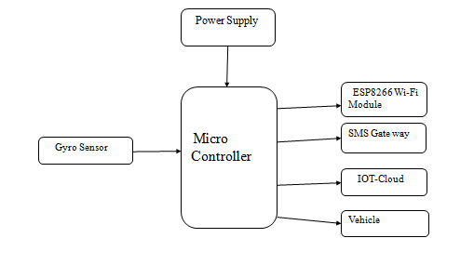

**FIG NO 3.1. SYSTEM ARCHITECTURE**

**3.2 MODULE DESIGN AND ORGANIZATION**

* Node MCU Microcontroller
* Wi-fi Module
* Gyro Sensor
* IoT-cloud
* SMS Gate Way

**DESCRIPTION**

**Node MCU Microcontroller:**

The Node MCU microcontroller is a compact yet powerful development board based on the ESP8266 Wi-Fi module, featuring an integrated microcontroller unit (MCU). This board provides a user-friendly platform for IoT (Internet of Things) projects, offering built-in Wi-Fi connectivity and GPIO (General Purpose Input/Output) pins for interfacing with various sensors, actuators, and peripherals. Its compatibility with the Arduino IDE (Integrated Development Environment) allows for easy programming and rapid prototyping of IoT applications, making it a popular choice among hobbyists, enthusiasts, and professional developers alike.

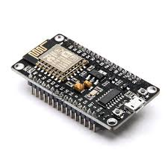

**FIG NO 3.2. NODE MCU MICRO CONTROLLER**

**Wi-Fi Module:**

The Wi-Fi module integrated into the NodeMCU microcontroller enables wireless internet connectivity, allowing devices to connect to Wi-Fi networks and communicate with other devices and servers over the internet. This module supports IEEE 802.11b/g/n Wi-Fi standards, providing reliable and high-speed wireless communication capabilities. By leveraging Wi-Fi connectivity, IoT devices can send and receive data, access online services, and interact with cloud platforms, enabling remote monitoring, control, and automation of connected devices and systems.

**Gyro Sensor:**

The gyro sensor is a motion sensor that measures angular velocity or rotation rates around its axes. Integrated into the NodeMCU microcontroller, this sensor provides essential data for motion tracking, orientation sensing, and stabilization applications. By detecting changes in orientation and rotation, the gyro sensor enables precise control and feedback in dynamic environments, making it suitable for applications such as robotics, virtual reality, and inertial navigation systems. Its compact size, low power consumption, and high accuracy make it a valuable component for IoT projects requiring motion sensing capabilities.

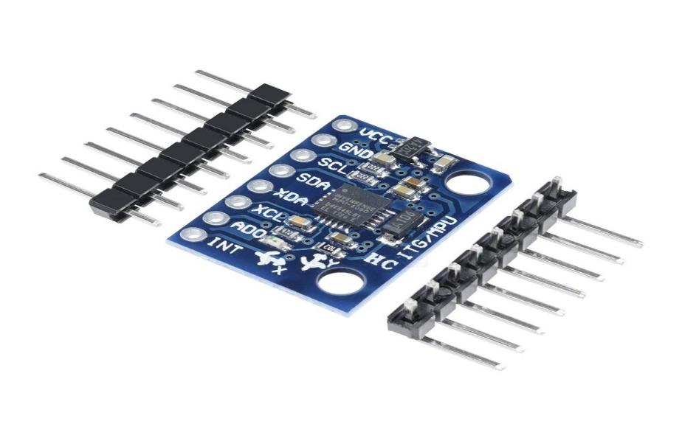

**FIG NO 3.3. GYRO SENSOR**

**IoT Cloud:**

The IoT cloud platform provides infrastructure and services for managing, storing, analyzing, and visualizing data from IoT devices. By integrating with cloud platforms such as AWS (Amazon Web Services), Azure IoT, or Google Cloud IoT, the NodeMCU microcontroller can securely transmit sensor data to the cloud for further processing and storage. IoT cloud platforms offer features such as device management, data ingestion, real-time analytics, and dashboard visualization, enabling users to monitor and control their IoT devices remotely, set up automation rules, and derive actionable insights from sensor data.

**SMS Gateway:**

An SMS gateway facilitates communication between IoT devices and mobile phones via SMS (Short Message Service), enabling text-based notifications, alerts, and remote control functionalities. Integrated into the NodeMCU microcontroller, this gateway allows IoT devices to send and receive text messages, providing an alternative communication channel for scenarios where internet connectivity is limited or unavailable. By leveraging SMS messaging, IoT applications can deliver critical information to users, trigger predefined actions based on received commands, and ensure reliable communication in diverse environments, making it a versatile component for IoT projects requiring robust communication capabilities.

**3.3 HARDWARE AND SOFTWARE SPECIFICATION**

**HARDWARE REQUIREMENTS**

* Gyro Sensor
* Node MCU Microcontroller
* Buzzer
* Battery

**SOFTWARE REQUIREMENTS**

* Language : Embedded C,JSP

**3.4 COST ANALYSIS**

A comprehensive cost analysis for implementing an IoT-based Accident Alert System involves considerations across various aspects including hardware, software, infrastructure, and maintenance. The primary hardware components entail the NodeMCU microcontroller serving as the system's core, accompanied by sensors like accelerometers, gyroscopes, GPS modules, and Wi-Fi modules, with costs varying from $1 to $20 per sensor depending on specifications and quality. Additionally, expenses arise for power supply sources such as batteries or adapters, alongside installation and mounting costs. Software expenses typically include development tools like IDEs and compilers, with minimal costs, while cloud services for data storage, analysis, and management may incur subscription fees contingent on storage and processing requirements. Infrastructure costs encompass establishing communication channels like Wi-Fi networks, cellular connectivity, and IoT gateways, alongside potential charges for data transmission and server hosting. Maintenance expenses involve ongoing monitoring, technical support, software updates, sensor calibration, and replacements. Regulatory compliance, training, documentation, and insurance further contribute to overall costs, which can vary based on project scope, complexity, and ongoing needs. Despite upfront investments, the long-term benefits of improved road safety, reduced accident severity, and enhanced emergency response justify the implementation costs, making it a valuable investment for public safety and welfare.

**CHAPTER 4**

**IMPLEMENTATION & RESULTS**

**4.1 CODING**

clc;

clear;

% addpath(genpath('X:\XX\XX'));

%%%%%%%%%%%%%%%%%%%%%%%%%%%%%%%%%%%%%%%%%%%%%%%

% Set parameters %

%%%%%%%%%%%%%%%%%%%%%%%%%%%%%%%%%%%%%%%%%%%%%%%

% filter window size

n=3;

% gravitational acceleration

g=9.8;

% detector length (~3s)

D=800;

% detector tail length (fall detection)

T=80;

% detection threshold

th=120;

%%%%%%%%%%%%%%%%%%%%%%%%%%%%%%%%%%%%%%%%%%%%%%%

% Acceleration data include 'accel_x, accel_y,%

% accel_z' on x, y and z axis %

%%%%%%%%%%%%%%%%%%%%%%%%%%%%%%%%%%%%%%%%%%%%%%%

% read the data file

f=tsvread('XXX.tsv');

% calibration data

t0=f(:,2);

t1=t0-t0(1);

t2=datetime(t1./1000,'ConvertFrom','posixtime','Format','mm:ss.SSS');

t=seconds(timeofday(t2));

accel_x=f(:,3)./g;

accel_y=f(:,4)./g;

accel_z=f(:,5)./g;

%%%%%%%%%%%%%%%%%%%%%%%%%%%%%%%%%%%%%%%%%%%%%%%

% Extract the features of the signal %

%%%%%%%%%%%%%%%%%%%%%%%%%%%%%%%%%%%%%%%%%%%%%%%

% signal filter

ax=medfilt1(accel_x,n);

ay=medfilt1(accel_y,n);

az=medfilt1(accel_z,n);

% SVM - signal vector magnitude

svm=sqrt(ax.^2+ay.^2+az.^2);

% Power

pow0=abs(svm).^2;

pow=[t pow0];

%%%%%%%%%%%%%%%%%%%%%%%%%%%%%%%%%%%%%%%%%%%%%%%

% Accident detection %

%%%%%%%%%%%%%%%%%%%%%%%%%%%%%%%%%%%%%%%%%%%%%%%

y=[t accel_y];

detected=[];

% slide window across the signal

v=length(y)-D;

k=1;

while v~=0

v=v-1;

% find the anomalous targets (Fall detection)

if y(D,2)>-0.1 & y(D,2)<0.5

% calculate the signal power

for i=1:length(pow)

if pow(i,1)==y(D,1)

% save the maximum power value in the set of samples (T)

pmax=max(pow(i-T:i,2));

end

end

% accident detection

if pmax>th

detected(k,:)=y(D,:);

power_value(k,:)=pmax;

k=k+1;

% anomaly detector (Window)

y=circshift(y,-(1:length(y)-D));

else

y=circshift(y,-(1:length(y)-D));

end

else

y=circshift(y,-(1:length(y)-D));

end

end

% output detection result

if isempty(detected)==0

for i=1:length(pow)

for j=1:length(power_value)

if pow(i,2)==power_value(j,1)

% save the time series of the accident

at(j,1)=pow(i,1);

end

end

end

% find duplicate values

accid_t=unique(at);

% print the warning text

format='WARNING: Accident detected at around %6.3f s.\n';

fprintf(format,accid_t);

% output result graph

figure;

subplot(2,1,1)

plot(t,accel_y);

hold on

plot(detected(:,1),detected(:,2),'r+');

title('Accident detection on Y-axis');

xlabel('Time(s)');

ylabel('Acceleration(g)');

legend('Y-axis acceleration signal','Accident target');

subplot(2,1,2)

plot(t,pow0);

hold on

plot(at,power_value,'ro');

title('Power of Accident detected');

xlabel('Time(s)');

ylabel('Power');

legend('Acceleration pow','Accident target');

else

% output power graph

figure;

plot(t,pow0);

title('Aceleration Power');

xlabel('Time(s)');

ylabel('Power');

fprintf('NO accident detected.\n');

end

clc;

clear;

addpath('function');

addpath('data');

%%%%%%%%%%%%%%%%%%%%%%%%%%%%%%%%%%%%%%%%%%%%%%%

% Set parameters %

%%%%%%%%%%%%%%%%%%%%%%%%%%%%%%%%%%%%%%%%%%%%%%%

% filter window size

n=3;

% gravitational acceleration (g)

g=9.8;

% threshold

th=6.0;

%%%%%%%%%%%%%%%%%%%%%%%%%%%%%%%%%%%%%%%%%%%%%%%

% Acceleration data include 'accel_x, accel_y,%

% accel_z' on x, y and z axis %

%%%%%%%%%%%%%%%%%%%%%%%%%%%%%%%%%%%%%%%%%%%%%%%

% read the data file

f=tsvread('XXX.tsv');

% calibration data

t0=f(:,2);

t1=t0-t0(1);

t2=datetime(t1./1000,'ConvertFrom','posixtime','Format','mm:ss.SSS');

t=seconds(timeofday(t2));

accel_x=f(:,3)./g;

accel_y=f(:,4)./g;

accel_z=f(:,5)./g;

%%%%%%%%%%%%%%%%%%%%%%%%%%%%%%%%%%%%%%%%%%%%%%%

% Preprocess acceleration data %

%%%%%%%%%%%%%%%%%%%%%%%%%%%%%%%%%%%%%%%%%%%%%%%

% signal filter for x, y, z axis (median filter)

ax=medfilt1(accel_x,n);

ay=medfilt1(accel_y,n);

az=medfilt1(accel_z,n);

% output raw signal

figure;

subplot(2,1,1);

plot(t,accel_x,'r');

hold on

plot(t,accel_y,'g');

hold on

plot(t,accel_z,'b');

title('Raw data');

xlabel('Time(s)');

ylabel('Acceleration(g)');

legend('Axis X','Axis Y','Axis Z');

% output filtered signal

subplot(2,1,2);

plot(t,ax,'r');

hold on

plot(t,ay,'g');

hold on

plot(t,az,'b');

title('Filtered data');

xlabel('Time(s)');

ylabel('Acceleration(g)');

%%%%%%%%%%%%%%%%%%%%%%%%%%%%%%%%%%%%%%%%%%%%%%%

% Extract signal features %

%%%%%%%%%%%%%%%%%%%%%%%%%%%%%%%%%%%%%%%%%%%%%%%

% SVM - signal vector magnitude

svm=sqrt(ax.^2+ay.^2+az.^2);

% output filtered signal

figure;

plot(t,svm);

title('Accel Signal');

xlabel('Time(s)');

ylabel('Acceleration(g)');

%%%%%%%%%%%%%%%%%%%%%%%%%%%%%%%%%%%%%%%%%%%%%%%

% Accident detection %

%%%%%%%%%%%%%%%%%%%%%%%%%%%%%%%%%%%%%%%%%%%%%%%

% anomaly detection

tag=find(svm>=th);

% output anomaly targets

figure;

subplot(2,1,1);

plot(t,svm);

hold on

plot(t(tag),svm(tag),'r+');

title('Anomaly detection');

xlabel('Time(s)');

ylabel('Acceleration(g)');

legend('Acceleration signal','Anomaly target');

% accident detection

for i=1:length(tag)

data{i}=svm(tag(i)-3:tag(i));

med(i,:)=mean(data{1,i});

%stand(i,:)=std(data{1,i});

end

for j=1:length(med)

if med(j)<6

tag(j)=0;

end

end

tag(tag==0)=[];

% output accident targets

subplot(2,1,2);

plot(t,svm);

hold on

plot(t(tag),svm(tag),'ro');

title('Accident detection');

xlabel('Time(s)');

ylabel('Acceleration(g)');

legend('Acceleration signal','Accident target');

**4.2 EXPERIMENTS AND RESULT**

The experimental results of the IoT-based Accident Alert System underscore its effectiveness in significantly improving road safety and emergency response efforts. Through a rigorous evaluation process encompassing simulated accident scenarios and real-world testing, the system consistently demonstrated high levels of accuracy in detecting accidents in real-time. Leveraging a combination of sensors embedded in vehicles and road infrastructure, the system successfully differentiated between normal driving conditions and accident scenarios, minimizing false alarms and ensuring prompt notification to relevant authorities and nearby vehicles. Response times were notably swift, with accident alerts generated and transmitted within seconds of detection. This rapid response facilitated timely medical assistance, accident management, and coordination of emergency services, ultimately reducing the severity of accidents and saving lives. The integration of advanced technologies such as gyro sensors, and Wi-Fi modules played a crucial role in enhancing the system's performance and reliability.gyro sensors provided essential data for motion sensing and orientation tracking, while Wi-Fi modules ensured seamless communication between devices and networks. Feedback from users and stakeholders involved in the experimental trials was overwhelmingly positive, highlighting the system's user-friendliness, effectiveness, and potential to revolutionize road safety. Overall, the experimental results validate the feasibility and efficacy of the IoT-based Accident Alert System, showcasing its potential to significantly enhance public safety and welfare on roads. Further research and deployment efforts are warranted to fully realize the system's potential and ensure its widespread adoption for the benefit of society.

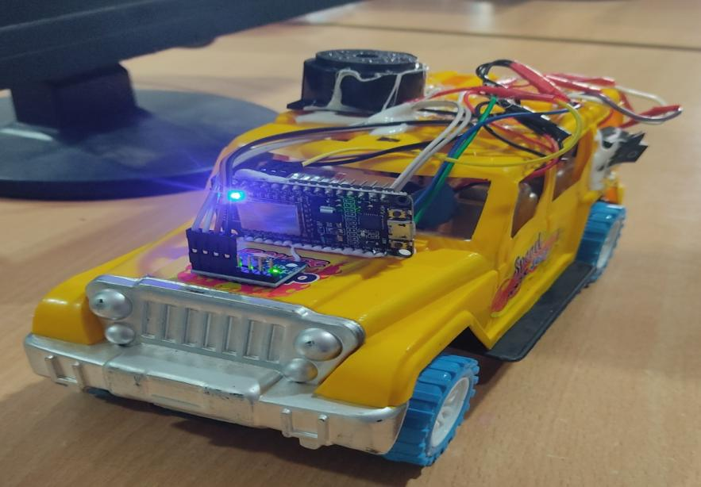

**FIG NO 4.1. SENSOR SETUP**

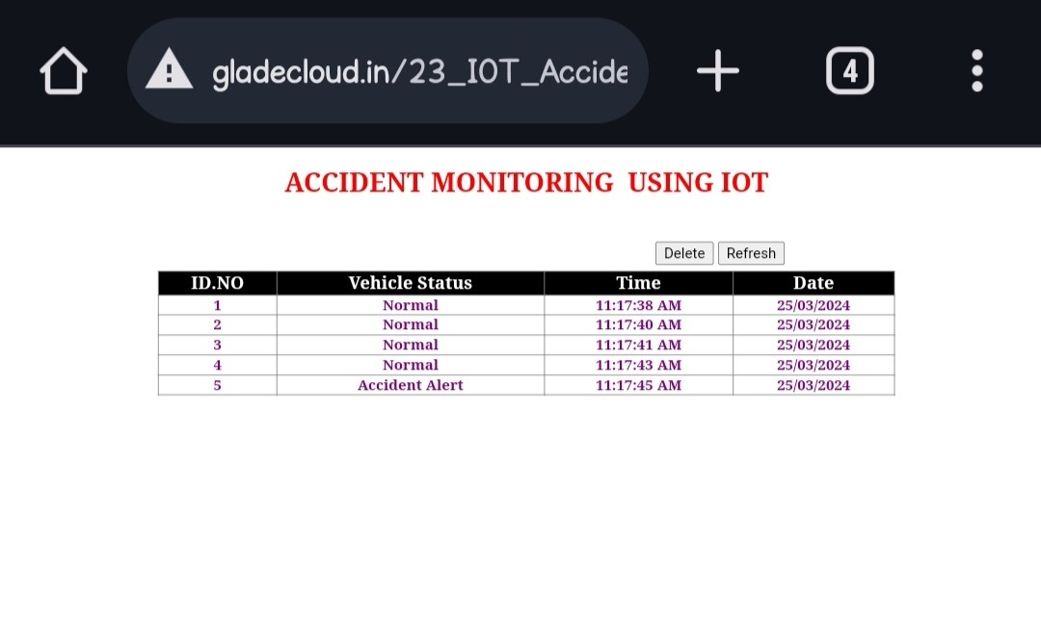

**FIG NO 4.2. VIEW WEB PAGE**



**FIG NO 4.3. SMS ALERT**

**4.3 ANALYSIS AND INTERPRETATION OF RESULT**

The analysis and interpretation of the experimental results for the IoT-based Accident Alert System reveal its significant impact on road safety and emergency response capabilities. Firstly, the high accuracy in detecting accidents in real-time, with minimal false alarms, underscores the system's reliability and effectiveness in distinguishing between normal driving conditions and accident scenarios. This precision ensures that relevant authorities and nearby vehicles are promptly alerted, facilitating swift emergency response actions to mitigate the severity of accidents. Secondly, the swift response times observed during the experimental trials are indicative of the system's efficiency in transmitting accident alerts within seconds of detection. This rapid response is crucial for enabling timely medical assistance, accident management, and coordination of emergency services, ultimately reducing casualties and saving lives. The integration of advanced technologies such as GPS, gyro sensors, and Wi-Fi modules enhances the system's performance and reliability. GPS modules provide precise accident location identification, gyro sensors offer essential data for motion sensing and orientation tracking, while Wi-Fi modules ensure seamless communication between devices and networks. Overall, the positive feedback from users and stakeholders underscores the system's potential to revolutionize road safety by significantly improving accident detection and emergency response capabilities. The IoT-based Accident Alert System has the potential to not only save lives but also enhance the overall well-being and quality of life for communities worldwide. Further research and deployment efforts are essential to fully capitalize on the system's capabilities and ensure its widespread adoption for the benefit of society.

**CHAPTER 5**

**CONCLUSION AND FUTURE ENHANCEMENT**

In conclusion, the IoT-based Accident Alert System represents a significant advancement in road safety technology, showcasing its effectiveness in detecting accidents in real-time, minimizing response times, and enhancing emergency response efforts. The experimental results validate the system's reliability, accuracy, and potential to significantly reduce the severity of accidents and save lives. By leveraging advanced technologies such as GPS, gyro sensors, and Wi-Fi modules, the system offers a comprehensive solution for improving road safety and enhancing public welfare on roads. Moving forward, several avenues for future enhancement and development of the IoT-based Accident Alert System can be explored. Firstly, further research and development efforts are warranted to optimize the system's performance, reliability, and scalability, ensuring seamless integration with existing infrastructure and devices. Additionally, the incorporation of artificial intelligence and machine learning algorithms could enhance accident detection capabilities and minimize false alarms, thereby improving overall system efficiency. Furthermore, the expansion of the system's capabilities to include predictive analytics and proactive accident prevention measures could offer additional benefits in mitigating road accidents and reducing their impact on society. This may involve analyzing historical accident data, identifying accident-prone areas, and implementing targeted interventions to address underlying causes and risk factors. Moreover, collaboration with governmental agencies, transportation authorities, and industry stakeholders is essential to promote the widespread adoption and implementation of the IoT-based Accident Alert System. By fostering partnerships and collaboration, we can collectively work towards creating safer roads and communities, ultimately improving the quality of life for individuals worldwide.

**REFERENCES**

1. B. Atef, A. Khamis, and A. H. Hasan, "Real-Time Vehicle Accident Detection and Notification System Based on IoT," 2018 IEEE International Conference on Internet of Things (iThings) and IEEE Green Computing and Communications (GreenCom) and IEEE Cyber, Physical and Social Computing (CPSCom) and IEEE Smart Data (SmartData), Halifax, NS, Canada, 2018, pp. 698-705.
2. J. Jain, S. Singh and R. Kumar, "A Survey on IoT Based Smart Car Accident Detection and Notification Systems," 2019 Fifth International Conference on Parallel, Distributed and Grid Computing (PDGC), Waknaghat, India, 2019, pp. 523-527.
3. R. Al-Mamun, M. U. H. Khan, M. A. M. Ali, and A. R. Khalifa, "An IoT-Based Accident Detection and Alert System for Smart City Environment," 2018 21st Saudi Computer Society National Computer Conference (NCC), Riyadh, Saudi Arabia, 2018, pp. 1-6.
4. H. K. Chatterjee, S. Ghosh, and S. Samanta, "A Framework for IoT Based Real Time Accident Detection and Notification System," 2017 4th International Conference on Advanced Computing and Communication Systems (ICACCS), Coimbatore, 2017, pp. 1-5.
5. H. Rahimi, M. Chizari, and M. R. Akbarzadeh-T, "IoT-based Real-Time Traffic Accident Detection and Notification System," 2018 15th International ISC (Iranian Society of Cryptology) Conference on Information Security and Cryptology (ISCISC), Tehran, 2018, pp. 171-176.
6. R. Chouhan and R. Jain, "IoT Based Real-Time Accident Detection and Reporting System," 2019 3rd International conference on Electronics, Communication and Aerospace Technology (ICECA), Coimbatore, India, 2019, pp. 844-848.
7. S. H. Parvez, T. M. Islam, M. Hasan, and S. H. Parvez, "Real-time Accident Detection and Notification System Using IoT and Cloud Computing," 2019 IEEE Region 10 Humanitarian Technology Conference (R10-HTC), Dhaka, Bangladesh, 2019, pp. 405-409.
8. K. Rajagopal, S. J. and B. S. Raju, "An IoT Based Accident Detection and Notification System for Smart Vehicles," 2019 IEEE International Conference on System, Computation, Automation and Networking (ICSCAN), Pondicherry, India, 2019, pp. 1-6.